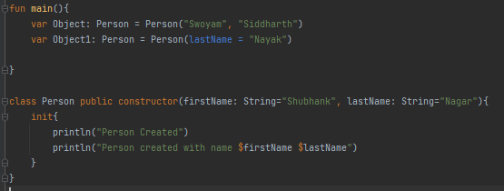

In the above example, the following features are displayed

* Constructor of a class
* Creating a class
* Default parameters of the class
* Default Customers

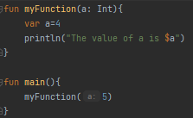

Kotlin allows you to create variables with the same names as parameters inside a function. In the above code, the value of a passed as a parameter is 5 but as we have declared a variable **a** with value as 4, whenever we will print **a** it will give value as 4

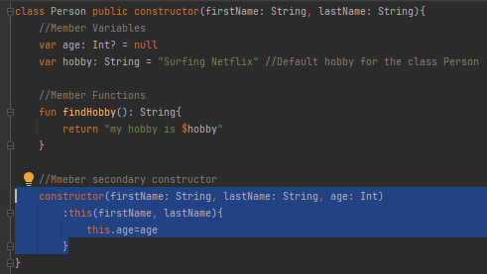

Creating a secondary member constructor for a class

  
This is how you declare a variable that you are going to initialize later on

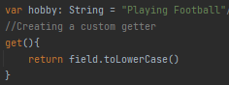  
This is how you define a custom **getter** for a variable in a class

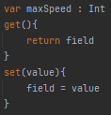  
This is the default **getter** and **setter** that is generated whenever a variable is declared

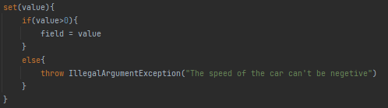  
Making customized error message while setting the value for a variable in a class

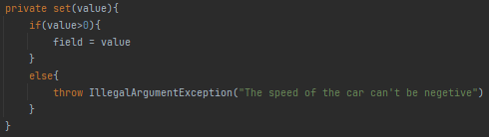  
You can make the setter of the variable private in order to prevent setting the value from outside the class. Thin increases the security of the program

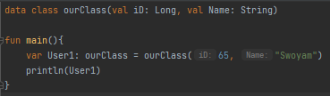  
This is how to use Data Classes

  
We can also call the destructor that is we can allocate the components of a data class into one or more variables of their respective data types

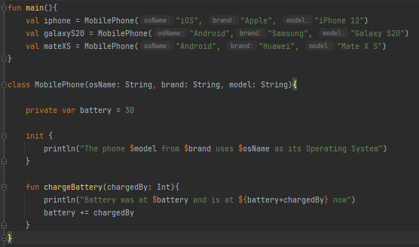  
One of these example of using classes, changing the value of their private variables by using member functions, and more.